Poster Presentation

Assessment of the Realistic Performance of Orbital™ High Payload Device Automatically Filled by Drum Lab with Model Fluticasone Propionate Blends
- Cristina Rey-Blanes¹ & Reanne Beaird¹, Norma Ulrich², Katarzyna Epeslidis², Niall Doherty¹, William J Ganley¹, Antonia Zapata del Bano¹, Jonathan Tournaire³, Irene Rossi¹

¹Nanopharm Ltd, An Aptar Pharma Company, Grange Road, Cwmbran NP44 3WY, United Kingdom

²Harro Hӧfliger Verpackungsmaschinen GmbH, Helmholtzstraße 4, Allmersbach i.T. 71573, Germany

³Aptar Pharma SAS, Route des Falaises, Le Vaudreuil 27100, France

Introduction
Lung diseases such as cystic fibrosis, tuberculosis and infection of the lung are often treated systemically through oral or intravenous therapies, leading to prolonged treatment times and lack of direct targeting of the disease. Therefore, high payload dry powder inhalers (DPI) have become an industry focus both from a formulation and device perspective. Orbital™ device is a single dose DPI capable of delivering large payloads to the lungs (50 mg – 400 mg) over several inhalations from a single reservoir of powder [1].
The purpose of this study was to assess the realistic aerodynamic performance of Orbital when automatically filled by drum. Two formulations each contained Fluticasone Propionate (FP) were employed. FP was selected as a model cohesive active pharmaceutical ingredient (API) due to its charge retention and tendency to agglomerate.

Materials and Methods
Two formulations were prepared: Blend 1 (FP:magnesium stearate = 99.0:1.0% w/w) manufactured using a Turbula® Low Shear Mixer (WAB, CH) at 22 rpm for 20 minutes and Blend 2 (lactose LH200:FP = 50:50% w/w), manufactured using isothermal Dry Particle Coating (iDPC, Aston Particle Technologies, UK) [2].
Orbital (Aptar Pharma, FR) was tested in its prototype single use configuration (puck reservoir with 0.6 or 0.9 mm single hole diameter). The device was filled at two fill weights (125 mg and 250 mg) using the Drum Lab (Harro Höfliger, DE) with a 50 mm³ drum. Puck orifice diameter and fill weights were selected based on results previously collected.
Realistic aerodynamic particle size distribution (rAPSD) was measured using a coated (brij-35: glycerol: ethanol: MilliQ water = 1.7: 38: 54: 6.3% w/v) medium-size anatomical throat (AT; Emmace Consulting, SE), a Next Generation Impactor (Copley Scientific, UK) and a breathing simulator employing a healthy volunteer inhalation profile (46.44 L/min of Peak Inspiratory Flow Rate with 5.08 s of Total Inhalation Time to achieve 3.13 L of Total Inhaled Volume). Delivered Dose (DD), Fine Particle Mass (FPM) and Fine Particle Fraction (FPF), calculated on DD, were reported.
The regional deposition model (RDM) of patterns achieved over the selected breathing profile and three successive inhalations were predicted using the National Council on Radiation Protection and Measurements (NCRP) model applied to a bolus aerosol. The model was used to predict deposition in the Weibel A lung model using the rAPSD data to calculate the FP percentage deposited in the following groupings of lung generations: extra-thoracic (ET, generation -1), tracheobronchial (BB, generations 0-8), bronchiolar (bb, generations 9-15), alveolar interstitial (AI, generations 16-23) and exhaled fraction (EX).

Results and Discussion
The average fill weights and relative standard deviation (RSD) obtained for the automatic filling of the two blends are presented in Table 1. Generally, RSD was ≤ 3.2%, even though it was not possible to fill Blend 1 at 250 mg fill weight due to the powder low density (0.18 g/cm3). Puck content uniformity was > 98.5% for Blend 2, indicating homogenous powder filling for the iDPC blend with the whole intended API dose loaded into the puck.
Orbital device allows for several breaths in order to inhale the full dose (Figure 1). For both blends tested, the cumulative delivered mass, and consequently API dose, depended on the puck hole diameter (0.9 > 0.6 mm) and loaded dose (only for 0.6 mm puck) with the highest percentage of delivered mass obtained by Blend 2 loaded at both fill weights in 0.9 mm single hole puck (> 65% after 5 inhalations). The presence of large lactose particles as carrier, even if just at 50% w/w, and the mixing technology employed, as previously observed, improved powder flowability determining a higher percentage of formulation delivered from Orbital in 5 consecutive inhalations.
Aerosol deposition performance data for the first 3 inhalations are showed in Table 1. As already reported in previous studies, a larger puck orifice allowed for a higher DD with an increased FPM, albeit FPF remained comparable. Despite the less favourable flow properties, Blend 1 delivered a higher FPM in 3 consecutive inhalations, due to the higher FP load and its particle very small size (D_{v},₅₀ 1.45 µm). For Blend 2 aerodynamic performance showed to be independent of the fill weight: same FPF at both 125 mg and 250 mg of powder filled.
Table 1. Fill weight, puck content uniformity and aerosol performance results (rAPSD) over three consecutive breaths.
Blend | Target fill weight (mg) | Puck hole diameter (mm) | Average fill weight (mg) | Puck content uniformity (%) | DD (mg) | FPM (mg) | FPF (%)
Blend 1 | 125 | 0.6 | 127.79 (1.56%) | N/A | 17.29 ± 4.18 | 10.23 ± 2.21 | 59.46 ± 3.74
Blend 1 | 125 | 0.9 | 125.59 (3.20%) | N/A | 34.28 ± 4.71 | 18.06 ± 2.25 | 52.53 ± 3.85
Blend 2 | 125 | 0.6 | 123.26 (2.05%) | 99.72 ± 2.59 | 20.78 ± 1.28 | 8.11 ± 0.32 | 38.59 ± 2.45
Blend 2 | 125 | 0.9 | 124.19 (2.45%) | 99.38 ± 0.36 | 27.84 ± 1.54 | 9.83 ± 0.06 | 35.04 ± 2.95
Blend 2 | 250 | 0.6 | 256.98 (3.00%) | 98.59* | 23.39 ± 0.71 | 9.37 ± 0.34 | 39.89 ± 1.86
Blend 2 | 250 | 0.9 | 253.91 (1.94%) | 98.52 ± 0.05 | 33.53 ± 0.50 | 12.50 ± 0.89 | 37.31 ± 2.66
*n=1
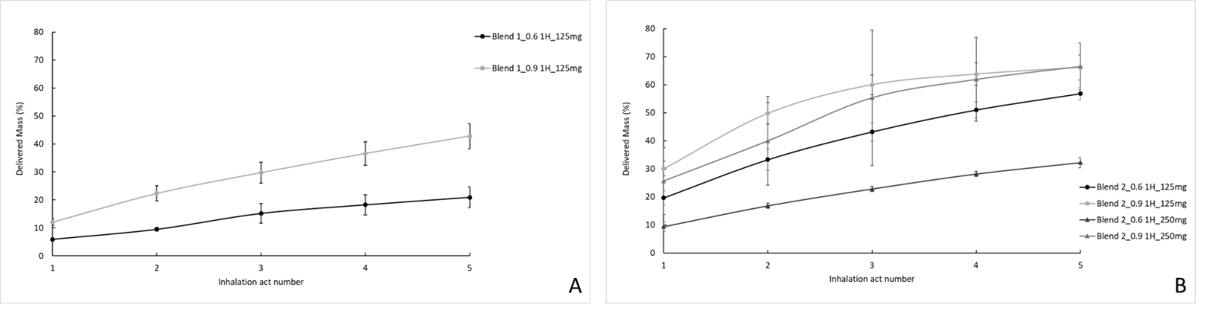
Figure 1. Delivered mass as cumulative percentage for 5 consecutive inhalation acts: panel A (Blend 1) and panel B (Blend 2).
The regional deposition model (RMD) showed that less FP was deposited into the extra thoracic (ET) region for Blend 1 when compared to Blend 2 (Figure 2), as expected from the higher FPM reported by Blend 1. In addition, and inverse correlation was observed in terms of ET versus alveolar (AI) deposition between the 0.6 and 0.9 mm puck, again independently of the fill weight for Blend 2.
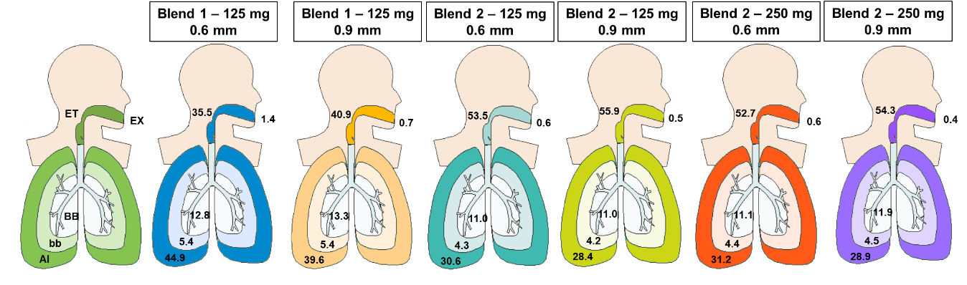
Figure 2. RDM: percentage (%) of FP deposition in the lung generations for the different blends and puck/fill weight combinations.

Conclusion
Orbital was successfully automatically filled by drum delivering consistent high performing, high payload DPI formulations of FP, a model cohesive API. The results obtained showed that formulation characteristics, drug load, mixing technology, and puck orifice diameter presented the biggest influence in the aerosolization performance. Next steps will focus on developing larger drum sizes which will allow to fill high doses of low density powders. Moreover, a comparison between manual and drum filled Orbital device with a range of powders presenting different physical and aerodynamic characteristics will be carried out.

References
- Young P.M. et al. J Aerosol Med Pulm 26(0), 1-10 (2013).
- Koner J.S. et al. Drug Delivery to the Lungs, Volume 33 (2022).

Poster Presentation

The effects of nebuliser position and humidification on aerosol drug delivery during non-invasive ventilation of adult patients
- Stephen Hoctor, Marc Mac Giolla Eain, Mary Joyce & Ronan MacLoughlin

¹R&D Science and Emerging Technologies, Aerogen Ltd., Galway Business Park, Galway, Ireland.

Introduction
Non-invasive ventilation (NIV) has increasingly been used in the treatment of patients undergoing respiratory distress [1]. NIV provides an alternative method of supporting a patient’s breathing by using positive end-expiratory pressure (PEEP) with either an oronasal, nasal or facemask [2]. It has seen an increase in use in critical care units in an effort to limit endotracheal intubation and its associated complications [3]. The use of concurrent aerosol delivery during non-invasive ventilation (NIV) may be exploited to facilitate delivery of a variety of prescribed medications for inhalation. There are numerous studies that have examined the factors that influence aerosol drug delivery in invasively ventilated patients [4,5]. These include nebuliser type, position in the circuit in relation to the ventilator and patient, humidification, and delivery interface. Few studies have investigated the factors affecting aerosol drug delivery in patients receiving NIV. This work focused on the influence of humidification and nebuliser placement on aerosol drug delivery in a dual limb NIV respiratory circuit to a simulated adult patient.

Methods
2000 µg of Albuterol Sulfate was aerosolised using a vibrating mesh nebuliser (VMN) (Aerogen Solo and Pro-X controller, Aerogen, IRE). NIV was delivered using a BellaVista 1000 ventilator (Vyaire, US), (IPAP: 15 cm H₂0, EPAP: 5 cm H₂0 with a humidifier (MR850, F&P, NZ) and a dual limb respiratory circuit (RT232, F&P, NZ). A non-vented NIV faskmask (RT046 F&P, NZ) was connected to an anatomically correct adult head model (LUCY) and a breathing simulator (BRS2100, Copley Scientific, UK) (BR: 15 BPM, Vt: 500 ml, I:E: 1.0:1.0). The VMN was placed at the mask elbow and on the inspiratory limb of the respiratory circuit, see Figure 1. The aerosol available at the level of the trachea was captured using an absolute filter (RespirGard II 303EU, Vyaire, US) and quantified using UV-spectrophotometry at 276 nm. Testing was completed in independent quintuplicate (n=5).

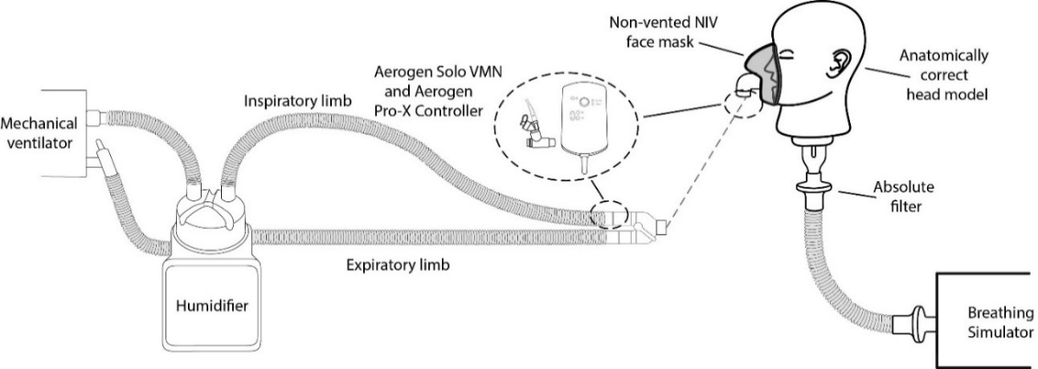
Figure 1: Schematic illustration of the experimental test setup.

Results
Results are expressed as a percentage of the nominal dose placed in the nebulisers medication cup (%) and presented in Figure 2.
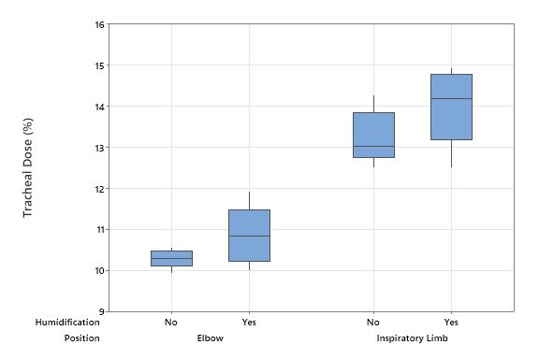
Figure 2: The effects of nebuliser position and humidification on the tracheal dose (%) in a NIV simulated adult patient.
Student’s T-tests were performed to determine significant differences in tracheal dose between the various nebuliser positions and the effects, if any, of humidification on the tracheal dose (%). P-values < 0.05 were considered statistically significant. The results of which are presented in Table 1.
Table 1: Statistical analysis of the influence of nebuliser position and circuit humidification on tracheal dose (%).
Nebuliser position | Humidification | Tracheal Dose (%)  (Avg ± SD) | P-Value
Elbow | Yes | 10.85 ± 0.72 | 0.132
Elbow | No | 10.28 ± 0.23 | 0.132
Inspiratory limb | Yes | 14.00 ± 0.94 | 0.209
Inspiratory limb | No | 13.53 ± 1.45 | 0.209
Elbow | Yes | 10.85 ± 0.72 | 0.004
Inspiratory limb | Yes | 14.00 ± 0.94 | 0.004
Elbow | No | 10.28 ± 0.23 | 0.002
Inspiratory limb | No | 13.53 ± 1.45 | 0.002

Conclusion
This study examined the effects of nebuliser placement and circuit humidification on aerosol drug delivery in a simulated NIV adult patient. The data showed that nebuliser placement had a significant effect on the dose of aerosol available for delivery at the tracheal level (%), P < 0.05, while circuit humidification had no significant effect, P > 0.05. The findings reported herein should help to inform clinicians as to the most efficient nebuliser placement and dual limb respiratory circuit arrangement to maximise aerosol drug delivery to NIV adult patients.

References
[1] Sutherasan Y, Ball L, Raimondo P, Caratto V, Sanguineti E, Costantino F, et al. Effects of ventilator settings, nebulizer and exhalation port position on albuterol delivery during non-invasive ventilation: An in-vitro study. BMC Pulm Med 2017;17:4–9. https://doi.org/10.1186/s12890-016-0347-5.
[2] Burns KEA, Adhikari NKJ, Keenan SP, Meade M. Use of non-invasive ventilation to wean critically ill adults off invasive ventilation: Meta-analysis and systematic review. BMJ 2009;338:1305–8. https://doi.org/10.1136/bmj.b1574.
[3] Hill NS. Noninvasive ventilation in chronic obstructive pulmonary disease. Respir Care 2004;49:72–89. https://doi.org/10.1513/AnnalsATS.201810-657CME.
[4] Ari A, Atalay OT, Harwood R, Sheard MM, Aljamhan EA, Fink JB. Influence of nebulizer type, position, and bias flow on aerosol drug delivery in simulated pediatric and adult lung models during mechanical ventilation. Respir Care 2010;55:845–51.
[5] Ari A, Areabi H, Fink JB. Evaluation of aerosol generator devices at 3 locations in humidified and non-humidified circuits during adult mechanical ventilation. Respir Care 2010;55:837–44.

Poster Presentation
INVESTIGATION OF MASS BALANCE ACHIEVED BY ANDERSEN THIRD GENERATION (A3G) CASCADE IMPACTOR DURING AERODYNAMIC PARTICLE SIZE ANALYSIS OF FLOVENT HFA
Rajesh Maheshwari¹, Brajesh Kumar Thakur², G.Kesavan², Ritu Laddha², Ravindra K Kotak², Apurv J Patel²
¹ Lab Automate Technologies Inc, Millburn, NJ, USA
² Zydus Cadila Healthcare Ltd, Ahmedabad, India

KEYWORDS: Andersen third generation (A3G), Andersen cascade impactor (ACI), aerodynamic particle size distribution (APSD), mass balance, fluticasone propionate

INTRODUCTION
The Andersen Cascade Impactor (ACI), and Next Generation Impactor (NGI) were designed for manual operation, which makes data generation slow and prone to operator-induced variability [1]. Since measurement of aerodynamic particle size distribution (APSD) is of critical importance to the development of inhaled aerosol products, and replicated testing is required during basic formulation, bioequivalence, and stability studies, these disadvantages can slow down product development and complicate the interpretation of results, which potentially leads to longer approval times. The Andersen third generation (A3G) cascade impactor was designed to take advantage of the validated geometry and particle sizing capabilities of the conventional ACI, but through the use of robotics, reduce the APSD sample preparation time to less than 25 minutes per run. In this abstract we investigate the ability of the A3G to consistently yield a high mass balance during ASPD experiments using Flovent® HFA pMDI. A high and reproducible mass balance is an important validation step in the aerodynamic sizing of inhaled products.
MATERIALS AND METHODS
Test Article: Flovent HFA (GlaxoSmithKline, fluticasone propionate inhalation aerosol, with a Label Claim of 220 mcg per spray) was used as purchased.
Fluticasone Assay: A reverse phase High Performance Liquid Chromatography (HPLC) method for detection of fluticasone was developed based on the corresponding United States Pharmacopeial monograph (USP-39) [2]. Fluticasone propionate API and HPLC grade reagents (Zydus Cadila Healtcare Ltd., Gujarat, India) were used for assay development on a Shimadzu LC-2010C HPLC equipped with a XTerra RP 18 (5 µm) column maintained at 40 °C. Injection volume was 50 µL, detection was at 239 nm and the total run time was 25 min. The mobile phase was comprised of acetonitrile and buffer solution (50:50 %v/v). The buffer solution contained 0.01M of sodium dodecyl sulfate and 0.1 %v/v glacial acetic acid in 20 %v/v aqueous methanol. The column was isocratically eluted at a flow rate of 2.0 mL/min.
A3G Design and Operation: The A3G is able to robotically assemble, disassemble, and recover drug from the stages of an Andersen Cascade Impactor before automatically cleaning, drying and reassembling column of stages containing impaction plates, and the terminal filter. Only the USP induction port, mouthpiece adaptor and inhaler must be mounted and dismounted manually for drug recovery. The equipment is described in detail elsewhere [3, 4], but basically has two operational systems. (1) a Collapsed Stage Column in which aerosol particles are fractionated according to their aerodynamic size under controlled air flow, and (2) an Isolator Column, in which individual ACI stages and plates are separated and enclosed in sealed chambers to facilitate drug recovery by quantitative washing of all internal surfaces. Unlike the conventional ACI, the A3G accomplishes these operations repeatedly without operator intervention, and has the additional benefit of delivering the programmed volume of drug recovery solvent into each sealed chamber followed by programmed rocking a fixed number of times. The rocking algorithms used in the A3G are designed to force sample recovery solution through the stage jets to enhance drug dissolution and recovery. A subassembly of the A3G contains pumps, valves, and sample collection racks to accumulate samples for subsequent HPLC analysis. In these experiments the sample recovery solution was 60%v/v acetonitrile in water.

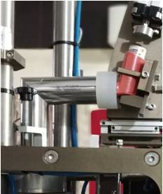
The pMDI is automatically agitated and discharged into the USP induction port by the Shaker/Actuator (Figure 1). Shake angle, acceleration, deceleration, velocity and number of times the pMDI is shaken are user selectable, as are the number of actuations and actuation force. The inhaler is robotically inserted in the mouthpiece adapter mounted on the induction port prior to each actuation.

Aerodynamic Particle Sizing and Sample Preparation: Using an Actuation Pressure of 4 kg/cm² with 12 shakes, a single canister of Flovent HFA, 220 mcg, was discharged 4 times during each of 8 runs into the autonomously running A3G operated at 28.3 L/min. The mouth piece and all impaction plates were then automatically washed using 20 ml of sample recovery solution for each, while all stages and the inlet cone were washed using 30 ml of sample recovery solution for each.
Figure 1. pMDI Shaker/Actuator with mouthpiece adapter mounted on the USP induction
RESULTS AND DISCUSSION
APSD results are shown in Table 1 as % of Label Claim recovered from each sample location. All shaking & actuation, particle fractionation by size within the Collapsed Stage Column, sample recovery in the Isolator Column, and collection of HPLC samples was fully automated, and except for interruptions caused by power outages, runs proceeded consecutively taking approximately 25 minutes each. The mean mass balance of fluticasone propionate was 100.5% of Label Claim of 220mcg with an RSD of 2.59%. On stages containing less the 0.3% Label Claim, RSD never exceeded 15%.

Table 1: Location-by-location fluticasone propionate recovery* following four sprays of Flovent HFA pMDI into the A3G Cascade Impactor using the automatic Shaker/Actuator (n=8).

Fluticasone Propionate  Recovery Location | Fluticasone Propionate Recovery (% Label Claim) For Each (Run)
Fluticasone Propionate  Recovery Location | (1) | (2) | (3) | (4) | (5) | (6) | (7) | (8) | Mean | %RSD
Mouthpiece Adaptor | 5.81 | 5.68 | 5.29 | 5.69 | 5.69 | 5.85 | 5.45 | 5.64 | 5.64 | 3.27
Induction Port | 48.24 | 45.32 | 45.87 | 45.56 | 47.96 | 44.13 | 41.74 | 43.02 | 45.23 | 4.97
Entrance Cone | 0.12 | 0.13 | 0.13 | 0.12 | 0.14 | 0.10 | 0.10 | 0.12 | 0.12 | 11.79
Stage-0 + Impaction Plate-1# | 3.03 | 2.83 | 2.88 | 2.76 | 2.90 | 3.06 | 2.69 | 3.45 | 2.95 | 8.04
Stage-1 + Impaction Plate-2 | 3.20 | 3.30 | 3.39 | 3.44 | 3.70 | 3.45 | 3.52 | 3.75 | 3.47 | 5.37
Stage-2 + Impaction Plate-3 | 5.05 | 5.11 | 5.31 | 5.55 | 5.92 | 5.63 | 5.62 | 5.82 | 5.50 | 5.76
Stage-3 + Impaction Plate-4 | 14.30 | 14.84 | 15.32 | 16.25 | 16.22 | 15.27 | 15.41 | 15.92 | 15.44 | 4.38
Stage-4 + Impaction Plate-6 | 15.05 | 14.95 | 15.50 | 16.32 | 15.86 | 15.39 | 15.49 | 15.78 | 15.54 | 2.86
Stage-5 + Impaction Plate-6 | 5.53 | 5.29 | 5.40 | 5.75 | 5.71 | 5.50 | 5.57 | 5.50 | 5.53 | 2.72
Stage-6+ Impaction Plate-7 | 0.70 | 0.67 | 0.68 | 0.72 | 0.72 | 0.72 | 0.68 | 0.72 | 0.70 | 3.09
Stage-7+ Impaction Plate-8 | 0.20 | 0.28 | 0.20 | 0.25 | 0.28 | 0.27 | 0.24 | 0.24 | 0.25 | 13.09
Stage Filter | 0.17 | 0.22 | 0.24 | 0.25 | 0.22 | 0.20 | 0.19 | 0.21 | 0.21 | 12.26
Mass Balance (total | 101.40 | 98.62 | 100.21 | 102.66 | 105.32 | 99.57 | 96.70 | 100.17 | 100.58 | 2.59

*Fluticasone propionate recovery is expressed as % Label Claim (220mcg per spray). Reported values are derived from four sprays.
#Impaction Plate 1 is below Stage 0, Impaction Plate 2 is below Stage 1, etc. Reported fluticasone propionate recovery includes drug from each Stage and its corresponding Impaction Plate.

CONCLUSION
Eight aerodynamic particle size determinations performed using the fully automated A3G cascade impactor resulted in mass balances between 96.70% to 105.32% of Label Claim for Flovent HFA. These values corroborate unpublished previous results suggesting the A3G is able to generate highly accurate and reproducible data. The A3G represents a fast and cost-effective alternative to manual Anderson cascade impactor methods. Furthermore, adoption of the automated A3G system retains the flexibility of the conventional ACI. For example, air flow rates of 60 to 90 L/min can be used by simply swapping in and out the appropriate ACI stages, which takes less than ten minutes.
ACKNOWLEDGEMENT
The authors of this work are grateful to the management and Analytical Research and Development Laboratory staff of Zydus Cadila Healthcare Limited for supporting this work.
REFERENCES
- Minimizing Variability of Cascade Impaction Measurements in Inhalers and Nebulizers by Bonam, M., Christopher, D., Cipolla, D. et al. AAPS PharmSciTech 9, 404–413 (2008). https://doi.org/10.1208/s12249-008-9045-9
- United States Pharmacopeia, USP 39-NF34. Rockville, MD. United States Pharmacopeial Concention. Monograph for Fluticasone Propionate Inhalation Aerosol, 4001-4005
- A3G - Automated Andersen Cascade Impactor by Maheshwari RK, Patel K, Patel V, Maheshwari KK, Javia A, Sutaria V. RDD Europe 2017. Volume 2, 2017: 249-254.
- Development Of A3G – Automated Andersen Cascade Impactor by Maheshwari RK, Sharma A, Maheshwari KK. RDD Asia 2014. Volume 1, 2014: 203-206.

Poster Presentation
Development of Beclomethasone pMDI Solution Using Low GWP HFA152a Propellant

- Giulia Carretta¹, Giada Varacca¹, Eride Quarta¹ Alberto Colombo², Giovanni Motta², Massimo Carrara² & Francesca Buttini¹
¹ Food and Drug Department, University of Parma, Parco Area delle Scienze 27/A, 43124 Parma, Italy.

² RxPack s.r.l, Via Mognago 47, 23848, Oggiono (LC), Italy.
Introduction
The present generation of Pressurized Metered Dose Inhalers (pMDIs) uses HFA propellants, which are potent greenhouse gases. As a result, research is currently being done to find propellants with a low Global Warming Potential (GWP) in an effort to reduce the carbon footprint ¹. In comparison to HFA134a (1300) and HFA227a (3350), one of these new propellants, HFA152a (coded as Zephex®), has a significantly lower environmental GWP of 124.
The aim of this project was to develop a pMDI product containing beclomethasone dipropionate (BDP) at a dose of 100 µg/actuation using HFA152a. Ethanol was added as a co-solvent to obtain an HFA-solution formulation and a DoE was employed to assess the effect of formulation composition and hardware components (orifice diameter and valve volume) on the product quality.
Experimental Methods
For the preparation of BDP pMDIs, 19 ml uncoated aluminium canisters from PressTeck (IT) were used, and they were equipped with KHFA metering valves and actuators made and supplied by RxPack s.r.l (IT).
The effect of critical material attributes (CMAs), such as ethanol content, valve volume, and actuator orifice diameter, on the critical quality attributes of the products in terms of Emitted Dose (ED), Coefficient of Variation (CV), and Fine Particle Fraction (FPF), was examined using an experimental full factorial design. Table 1 shows the CMAs at the two levels investigated.
Factors | Levels investigated
Ethanol Content (% w/w) | 8 – 12
Volume of the Valve (µl) | 50 – 63
Actuator Orifice Diameter (mm) | 0.25 – 0.3
Table 1: CMAs and level investigated for the determination of the lead product

The BDP ED test was carried out using a Unit Sampling Collecting Apparatus operated as specified in USP44 at flow rate of 28.3 L/min. The Next Generation Impactor (NGI) was operated at a flow rate of 30 L/min. For each experiment four shots were collected after can shaking.
Initial and re-priming requirements for the inhalers was assessed by storing the canisters for 48h in three different orientations: upright, horizontal and upside down. Following a shake of the inhaler prior to each actuation, the first four doses at the beginning of the product's life were examined. After storing the inhalers for an additional 48 hours as mentioned above, the doses #5 to #7 were then collected.
Results and Discussion
KHFA is an “open chamber” valve, the design of which prevents the loss of prime by ensuring that the metering chamber is fully filled before usage. The access channels of the formulation to the chamber are in fact sufficiently open, so that the formulation itself can easily remove and displace any vapor bubbles. None of the critical factors investigated showed significance on the BDP ED values (Model p-value = 0.735) which ranged between 75 – 98 µg. Furthermore, all ten doses analyzed fell within the limits required by the PhEur. However, the CV values of the eight products varied between 2.5% and 15.7%, thus indicating different dispersion of doses within the range. Figure 1a illustrates, by way of example, the trend of two products with high and low precision of the BDP ED values. Figure 1b illustrates KHFA valve.
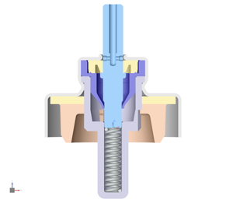
Figure 1a (on the left): Graphical representation of the BDP ED trend resulting from the combination of CMAs of two different product (Label claim 100 µg/shot). The yellow line represents the upper limit (125%), the orange one the lower limit (75%) of the mean value (grey line). Figure 1b (on the right).
The ANOVA test confirmed that the investigated factors had a significant effect on the CV value (Model p-value=0.0311). The Pareto chart in Figure 2 shows the significance and type of effect (positive or negative) of the factors and their interaction on the CV of ED. From the chart it is possible to conclude that the precision of the ED decreased with increasing valve volume, actuator orifice diameter and ethanol content.
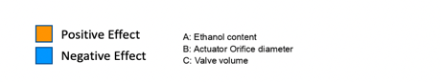
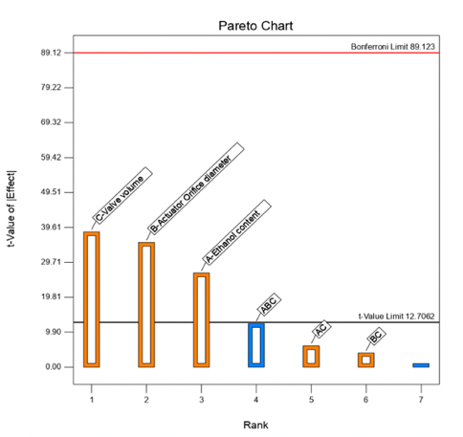

Figure 2: Graphic representation of the pareto chart obtained by performing an ANOVA test to evaluate how the variation of the factors studied impacts on the ED CV%.
Based in the above results a lead product consisting of 8% ethanol, 50 µl valve volume, and 0.25 mm orifice diameter was further characterized. The product showed an in vitro respirability of FPF of 57% and a small MMAD of 1.1 µm (Table 2). Furthermore, the technique of creating a BDP solution and atomizing it with particular device characteristics results in an extra-fine formulation with potential for high peripheral deposition, as achieved for the formulation in HFA134a. The BDP_HFA152a lead product's aerodynamic profile is similar to that of the Clenilexx (or Qvar), where the FPF was 69% and the BPD MMAD was 1.22 µm ².
Table 2: Aerodynamic parameters obtained by carrying out the complete characterization of the BDP_HFA152a lead product, ethanol content 8%w/w, actuator orifice diameter 0.25 mm (n=3 ± st dev).

Emitted Dose (µg) | Fine Particle Mass (µg) | Fine Particle Fraction (%) | Extra-Fine Particle Mass (µg) | Extra-Fine Particle Fraction (%) | MMAD (µm) | GSD
80.5 ± 2.2 | 45.8 ± 5.3 | 57.0 ± 7.0 | 37.0 ± 4.4 | 46.2 ± 5.6 | 1.11 ± 0.12 | 1.7 ± 0.1

The initial priming and re-priming test showed that the dose of BDP delivered at the beginning of the product’s life fell within the specification range in all storage pMDI orientations analyzed, confirming the effectiveness of the “open chamber” design. BDP delivered doses #5, #6 and #7, collected 48 hours after the last use, showed that also in this case, no re-priming was necessary as the amount of drug delivered was around 80 µg regardless of the orientation of the inhaler during its storage (Figure 3).

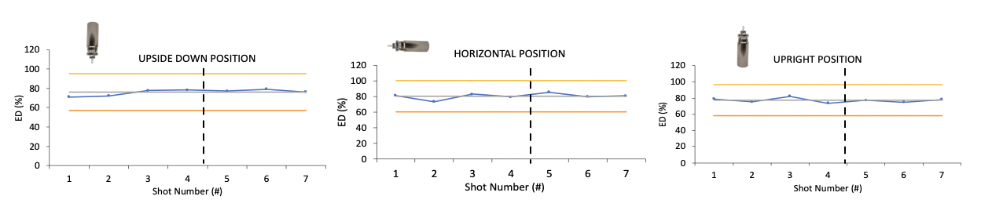
Figure 3: BDP ED (%) after storage the MDI inhalers in three different orientations. The first 4 doses were collected at the beginning of the product life and the 5 to 7 doses after 48 hours storage.
Conclusions
The study illustrates that, by optimizing characteristics of the formulation and of the pMDI device components, it was possible to obtain a BDP product with high respirability (FPF = 67%) using HFA152a. The KHFA-RxPack 50 µl valve showed high precision in product delivery (CV 2.5%) with the advantage of not requiring an initial priming or re-priming. Finally the inhalation of all doses avoids wasting the product, a poor sustainable action for the environment and for patient costs.
References
1. Wilkinson, A. J. K. & Anderson, G. Pharmaceut Med 34, 191–199 (2020).
2. Buttini, F. et al. Int J Pharm 465, 42–51 (2014).

Poster Presentation

Development of Inhalation Powders Containing Lactobacilli with Antimicrobial Activity Against Pseudomonas aeruginosa
- Stefania Glieca¹, Eride Quarta¹, Benedetta Bottari¹, Elena Bancalari¹, Erika Scaltriti², Martina Tambassi², Lisa Flammini¹, Simona Bertoni¹, Fabio Sonvico¹ & Francesca Buttini¹

¹ Food and Drug Department, University of Parma, Parco Area delle Scienze 27/a, Parma, 43125, Italy

² Risk Analysis and Genomic Epidemiology Unit, Istituto Zooprofilattico Sperimentale della Lombardia e dell'Emilia-Romagna, Strada dei Mercati, 13/A, Parma, 43126, Italy

Introduction
Although for many years lungs had been considered sterile, in the last decades the presence of a microbial community has been demonstrated. Furthermore, a correlation has been identified between the modification of the lung microbiota and respiratory diseases, such as asthma, chronic obstructive pulmonary disease, and airway infections in cystic fibrosis (CF) patients¹. Because of their beneficial effects on controlling Pseudomonas aeruginosa growth and their proven safety, Lactobacillus species are under investigation as probiotics for potentially preventing pulmonary infections^{2,3}. To date, clinical trials on the use of probiotics concern their oral administration, which effects should be mediated by the gut-lung axis ⁴. A novel and innovative approach could be to administer them directly to the lung, the primary site of infection.
The aim of the project was the development and characterization of three powders for inhalation containing different strains of probiotic bacteria, i.e. Lpb. plantarum, Lcb. rhamnosus and L. acidophilus. The challenge was to obtain a respirable powder able to maintain probiotics viability as well as their antimicrobial effect on P. aeruginosa.

Experimental methods
The three probiotics strains were propagated by two overnight subculturing steps at 30°C in De Man Rogosa Sharp broth (Oxoid, Ltd., UK), washed by centrifugation and then diluted at a 5*10⁹ cells/mL concentration with phosphate buffer saline (PBS). 50 mL aliquots of the bacterial suspension were spray-dried adding lactose and leucine in a 70:30 ratio, with a total excipient concentration of 1.25 % (w/v), employing a mini spray dryer B-290 (Buchi, CH). The other spray-dried conditions employed were inlet temperature at 145°C, air flow rate at 600 L/h, aspiration at 35 m³/h, feed rate at 3.5 mL/min and nozzle of 0.7 mm. The microparticles morphology was investigated by Scanning Electron Microscopy (SEM). The in vitro aerodynamic assessment was carried out by a Next Generation Impactor (NGI, Copley Scientific Limited, UK), aerosolizing the powder using a RS01® (Plastiape, IT). The viability of Lactic Acid Bacteria (LAB) before and after the powder production was investigated using the live/dead BacLight Bacterial Kit®. To evaluate the ability of the LAB to adhere to the epithelial cells of the lung, the spray-dried powders were deposited on A549 and Calu-3 cells and after 2h, the non-adherent bacteria were removed by washing with PBS. Adherent bacteria were quantified, and the % of adhesion was calculated as the ratio of adhered to deposited bacteria, in percentage. The capacity of the LAB in the powders to inhibit the P. aeruginosa growth in vitro was evaluated by a liquid co-colture assay. In detail, it was evaluated the growth of three P. aeruginosa strains, with different virulence, in the presence of a concentration of 10⁶ cells/mL of LAB obtained by suspending an adequate quantity of spray-dried powder in PBS.

Results and Discussion
Lpb. plantarum, Lcb. rhamnosus and L. acidophilus spray-dried powders, after an optimization of the formulation trough a design of experiments approach, were efficiently produced with a process yield higher than 80%. The viability of the LAB in the powder decreased of only 1 Log unit after the spray drying process, a value that is in agreement with what is reported in literature⁵. The SEM analysis revealed that the bacteria were inserted into a matrix of excipients organized in the form of collapsed particles with a maximum size of 3-4 µm (Figure 1A).
Aerodynamic deposition determined gravimetrically was, for all three LAB formulations, characterized by a high amount (30%) of powder deposited in the stages that collect particles with an aerodynamic diameter < 0.5 µm. The MMAD value was about 3 µm for all three formulations, with a FPF of 51.3%. However, gravimetric quantification does not allow to assess the composition of the powder deposited. The quantification of Lpb. plantarum cells, in fact, revealed that the powder deposited in the last stages was mostly composed by excipients, while LAB deposited in the stages which collect particles in the range 2-8 µm. This led to an increase in the MMAD to 5.28 µm and a FPF of 48.3%. This is reasonable considering that LABs have an intrinsic length that can vary from 0.5 to 10 µm, and it is certainly not possible to reduce their intrinsic size during the formulation, as they would no longer be viable.
The LABs capacity to adhere to lung cells and the antimicrobial effect of the powders are the main mechanisms that the host can benefit from, thus representing the discriminants for the choice of probiotic strains.
Lpb. plantarum had greater ability to adhere to host cell surface on both cell lines and this can be related to its higher resistance to the spray drying process which allows the retention of its extracellular proteins capable to interact with collagen, or mucus⁶ (Figure 1B). In fact, it is reported in literature that the spray drying process can damage Lcb. rhamnosus pili, involved in the adhesion, leading to a decrease in its capacity to adhere to cells compared with bacteria in suspension. Furthermore, because commensal bacteria have developed a mucus binding domain on their cell surface, Lpb. plantarum adhesion to Calu-3 cells was greater than that to A549.
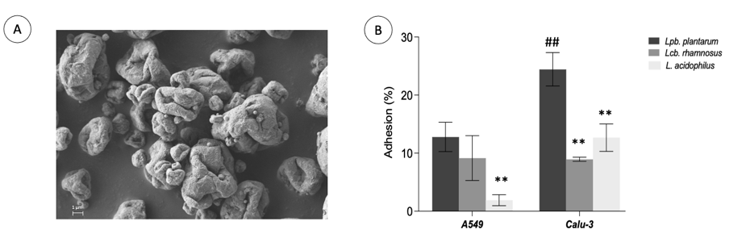
Figure 1. A: SEM image of the Lpb. plantarum spray-dried powder; B: Adhesion capacity of the three LAB spray-dried powders on A549 and Calu-3 cells (n=3); *p< 0.05, ** p < 0.01 vs. Lpb. plantarum; # p < 0.05, ## p < 0.01 vs Lpb. plantarum on A549.
Finally, it was demonstrated how Lpb. plantarum was the only LAB having a bactericidal effect against all P. aeruginosa strains tested (Figure 2A). On the other hand, Lcb. rhamnosus had a bacteriostatic effect while L. acidophilus significantly reduced the growth only of two bacterial strains. The ability of LAB to inhibit the growth of P. aeruginosa has been attributed in other works, where the antimicrobial activity was tested on the entire suspension of LABs, to their ability to release organic acids and to lower the pH of the environment ⁷. In this regard, we found that Lpb. plantarum, which showed a bactericidal effect, had the greatest acidifying capacity, leading to a decrease of the environment pH up to 3.71 (Figure 2B). On the other hand, the L. acidophilus, which had the least antimicrobial capacity, was the one which acidified the environment the least, with a pH of 4.27.
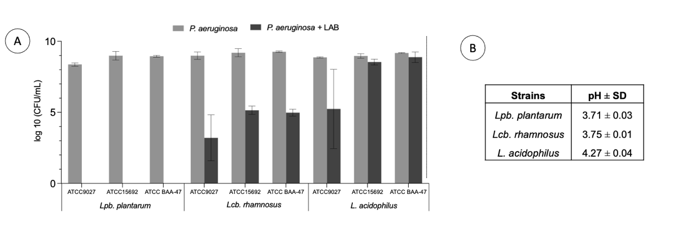
Figure 2. A: Antimicrobial activity of the three LABs spray-dried formulations on three different P. aeruginosa strains (n=3), *p < 0.05. vs P. aeruginosa in the absence of LABs. B: pH obtained in the culture medium of the three LABs spray-dried formulations.

Conclusions
Overall, the work demonstrates how, by applying a multidisciplinary approach, it was possible to obtain respirable powders containing viable probiotics which preserved their antimicrobial activity against P. aeruginosa, a clinically relevant pathogen in CF patients. The work represents a promising starting point to explore the modulation of the pulmonary microbiota following the administration of a probiotic directly in contact with the local microflora.

References
1. Zhang, D. et al. Front Microbiol 11, 1–14 (2020).
2. Spacova, I. et al. Microb Biotechnol 16, 99–115 (2023).
3. De Boeck, I., et al. Microb Biotechnol 14, 859–869 (2021).
4. Bruzzese, E. et al. Clinical Nutrition 26, 322–328 (2007).
5. Killeit, U. Deutsche Lebensmittel-Rundschau 118, (2022).
6. Sengupta, R. et al. Mediators Inflamm 2013, (2013).
7. Shokri, D. et al. Probiotics Antimicrob Proteins 10, 34–42 (2018).

Poster Presentation

Optimization of Spray-Drying Process Parameters for the Preparation of Ciprofloxacin-Quercetin Fixed-Dose Combination intended for inhalation
- Nasser Alhajj¹, Niall J. O'Reilly ^{1,2} & Helen Cathcart ¹

¹Pharmaceutical and Molecular Biotechnology Research Centre (PMBRC), South East Technological University, Cork Road Waterford, Ireland

²SSPC – The Science Foundation Ireland Research Centre for Pharmaceuticals, Ireland

Introduction
Spray drying is a well-established manufacturing technique for engineering micronized particles with well-controlled aerosolization-related properties ¹. A fine-tuning of the spray drying processing parameters can control the properties of the product, both at a powder level such as yield and residual moisture content (RMC) and at a particle level such as morphology and size distribution. The aim of this study was to understand and optimise the spray drying process of a ciprofloxacin-quercetin fixed dose combination intended for pulmonary administration. A 2⁴⁻¹ fractional factorial design of experiment (DoE) and multivariate data analysis along with principle component analysis (PCA)² were used to identify important process parameters and investigate correlations with particle characteristics to produce microparticles suitable for pulmonary drug delivery.

Methods
Spray-dried powders were prepared using Pro-CepT 4M8-TriX spray dryer (Zelzate, Belgium) with a nozzle orifice diameter of 0.4 mm. The feedstock solutions were prepared by dissolving ciprofloxacin and quercetin in water and ethanol, respectively. Then ciprofloxacin solution was added to quercetin solution under continuous stirring. The final solutions contained ciprofloxacin and quercetin at a mass ratio of 2:1, respectively, in ethanol and water at volume ratio 75:25, respectively. Four processing parameters were evaluated at 2 levels: solute concentration (0.5 and 1 %w/v), solution flow rate (pump speed 20 and 100%), atomizing air flow rate (6.5 and 9.5 L/min) and inlet temperature (100 and 180 °C). The remaining spray-drying process parameters (air flow = 0.3 m3/min and differential pressure over cyclone = 50 mBar) were kept constant for all experiments. The quality target product profile (QTPP) of the spray dried powder was defined as: the particles size and size distribution (D_{(v,50)} 1 – 5 µm), percentage yield (>50%) and residual moisture content (<5%). The particle size distribution was determined using a Mastersizer 2000 laser diffraction instrument (Malvern Instruments, UK) and the residual moisture content using a Q50 TGA Thermogravimetric Analyzer (TA instruments, UK). The aerosolization performance was investigated by loading 10 mg powder into a Cyclohaler device connected to a next generation impactor (NGI) at a flow rate of 60 L/min.

Result
A two-level, four-factor (2⁴⁻¹) half factorial design was developed and the correlations between dependent and independent variables were investigated using Minitab (Minitab Inc., Version 20, State College, PA, USA) statistical software. The DoE results indicated that the particle size D_{(v,50)} and D_{(v,90)} were affected by solution flow rate, atomizing air flow rate and inlet temperature while the span was mainly affected by the solute concentration and the atomizing air flow rate. The inlet temperature was the most important parameter affecting the RMC and the yield (Table 1 and Figure 1).

Table 1. ANOVA statistics and coefficients for the models obtained for the 2⁴⁻¹ fractional factorial design
Term | Aliased | D_{(v,10)}  (µm) | D_{(v,50)}  (µm) | D_{(v,90)}  (µm) | Span | Yield  (%) | RMC  (%)
Intercept |  | 0.717* | 2.183* | 8.065* | 4.132* | 45.89* | 2.831*
A (solute concentration) | BCD | 0.193 | 0.749 | -0.139 | -1.892* | 18.94* | 0.0100
B (solution flow rate) | ACD | 0.0375 | 0.2825* | 0.858* | - | 7.80* | 0.1255*
C (atomizing air flow rate) | ABD | -0.0333 | -0.1700* | -0.9267* | -0.4125* | -2.433 | -0.0362
D (inlet temperature) | ABC | -0.1025 | -0.4300* | -1.165* | - | -10.65* | -0.4772*
AB | CD | - | 0.1625 | 0.598 | - | 4.22 | 0.0308
AC | BD | -0.0317 | -0.1233 | 0.0133 | 0.3042* | -2.845 | -
AD | BC | - | -0.1800 | -0.585 | - | -2.40 | -
Model (p value)ª |  | 0.217 | 0.047 | 0.030 | 0.008 | 0.032 | 0.002
Lack of fit (p value)^{b} |  | 0.735 | 0.320 | 0.381 | 0.232 | 0.887 | 0.456
R² |  | 74.40% | 98.64% | 99.13% | 84.55% | 99.09% | 97.77%
Adjusted R² |  | 42.41% | 93.89% | 96.06% | 76.82% | 95.88% | 94.98%
Note: residual moisture content (RMC).
* Statistically significant at the 95% confidence level; ª Reference value for good model < 0.05; ^{b} Reference value for good model > 0.05.
A blue par present a term with positive effect; a red par present a term with negative effect; a gray par present a term not in the model; the vertical line defines the 95 percent confidence interval.
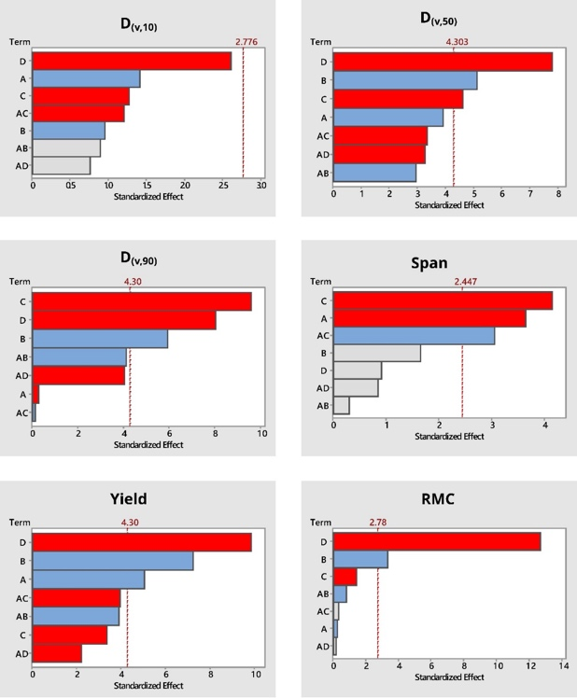
Figure 1. Pareto chart of the standardized effects. Factor abbreviations: A:Solute concentration (%w/v); B:Solution flow rate (%); C: Atomizing air nozzle flow rate (l/min); D:Inlet temperature (°C).
The processing parameters that combined a high solute concentration, high solution flow rate, low atomizing air flow and low inlet temperature produced powder with acceptable QTPP, i.e. D_{(v,50)} = 2.93 μm, yield = 71.30 % and RMC = 3.4%. However, this formulation has high D_{(v,90)} and span values of 8.01 μm and 2.5, respectively, which means that a large portion of the powder would deposit in the throat upon inhalation rather than reaching the deep lung.
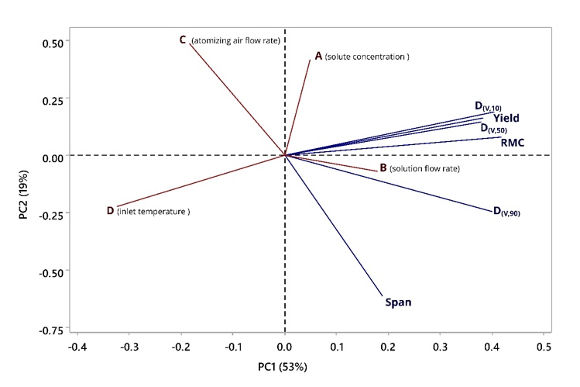
The PCA shows that 72% of the variation in the data set was described by the first two principle components, 53% by PC1 and 19% by PC2. Figure 2 presents the loading plot of PC1 and PC2.
Figure 2. Loading plot of PC1 and PC2.

Figure 1 and 2 shows that both D_{(v,90)} and span are influenced by atomizing air flow rate while D_{(v,50)}, yield and RMC are less impacted by atomizing air flow. Thus atomizing air flow rate was adjusted, while holding all other parameters at their previous values, to optimise D_{(v,90)} and span. The formulation was optimised using a desirability function. The optimised particles were prepared at atomizing air flow rate of 8.5 L/min and characterized with a D_{(v,90)} of 5.30 ± 0.23 µm and a span of 1.81 ± 0.05 (Table 2).

Table 2. Comparison between actual and predicted values of dependent variables under desirability function. Predictions are expressed as mean ± 95% confidence intervals.
Output parameters | Predicted | Predicted lower range | Predicted upper range | Actual | *F of acceptable QTPP
D_{(v,10)} (µm) | 0.758 | 0.283 | 1.232 | 0.92 ± 0.04 | 0.87±0.03
D_{(v,50)} (µm) | 2.374 | 1.793 | 2.955 | 2.42 ± 0.09 | 2.93±0.07
D_{(v,90)} (µm) | 6.108 | 4.583 | 7.633 | 5.30 ± 0.23 | 8.01±0.37
Span | 2.199 | 0.783 | 3.614 | 1.81 ± 0.05 | 2.50±0.13
Yield (%) | 60.86 | 49.49 | 72.24 | 71.13 ±1.08 | 71.30
Residual moisture content (RMC; %) | 3.279 | 2.728 | 3.830 | 3.44 ± 0.19 | 3.400
* The formulation of acceptable QTPP is shown here for comparison.

The optimised formulation exhibited favourable in vitro aerosolization performance with MMAD of about 2.3 µm, emitted dose > 80% and fine particle fractions > 70% (Table 3).

Table 3. In vitro aerodynamic parameters of the optimized spray-dried formulation.
 | MMAD (µm) | GSD | RD (%) | ED (%) | FPF (%)
Ciprofloxacin | 2.31 ± 0.06 | 2.03 ± 0.11 | 98.32 ± 5.52 | 88.26 ± 0.32 | 73.74 ± 1.23
Quercetin | 2.24 ± 0.05 | 1.78 ± 0.03 | 92.77 ± 8.54 | 83.64 ± 0.2 | 74.02 ± 2.02

Conclusion
Effects of solute concentration, solution flow rate, atomizing air flow rate and inlet temperature were evaluated to screen the spray-drying process parameters of significance on the QTPP. The QTPP was achieved in the formulation produced at solute concentration of 1 %w/v, solution flow rate of 100% (pump speed), atomizing air flow of 6.5 (L/min) and inlet temperature of 100 (°C). This formulation was optimised to further improve its D_{(v,90)} and span for pulmonary delivery purpose. The optimised formulation exhibited excellent aerosolization performance with MMAD of about 2.3 µm, emitted dose > 80% and fine particle fractions > 70%. The achieved FPF is much higher than those of commercialized orally inhaled carrier based dry powder formulations which estimated to be below 30%. ³

References
1. Alhajj, N., O’Reilly, N. J. & Cathcart, H. Designing enhanced spray dried particles for inhalation: A review of the impact of excipients and processing parameters on particle properties. Powder Technology vol. 384 313–331 (2021).
2. Rajalahti, T. & Kvalheim, O. M. Multivariate data analysis in pharmaceutics: A tutorial review. Int. J. Pharm. 417, 280–290 (2011).
3. Lechanteur, A. & Evrard, B. Influence of Composition and Spray-Drying Process Parameters on Carrier-Free DPI Properties and Behaviors in the Lung: A review. Pharmaceutics vol. 12 (2020).

What Will Guide You? Choosing The Correct Inhaler (Oral Presentation)
Dr. Philippe Rogueda
Merxin Ltd., UK
Abstract
How do you choose an inhaler device? There are so many choices, how will you choose?
There are many dimensions to choosing a device and many devices to choose from. We like to think that devices are chosen from objective data: performance (i.e. fine particle fraction). In reality the choice of a device has not so much to do with performance as a company historical choices.
Nebulisers are sold off the shelf and standardised. pMDIs are commoditised, like nasal devices, this is the domain of the pick and match: can, valve, actuator, counter, pump. DPIs are more bespoke with a noted enthusiasm for new moelcules for capsule DPIs, despite the fact that blockbuster DPIs are multidose DPIs. SMis are only just becoming available widely and are changing the inhaler market.
Trends can be noted between companies: AstraZeneca is committed to DPIs; GSK has a legacy of pMDI products but derives the bulk of the revenue of its inhalation franchise from an multidose DPI; Chiesi is investing in new HFA pMDIs; while Pfizer evaluates SMIs.
The dimensions of a device choice include:
- company’s previous choices
- company’s risk profile
- usability and acceptability of the device
- I.P. protection
- availability
- target therapy
- formulation
- performance
The device that will be retained in a development program will be a fine balance between these dimensions and will be a compromise between the project stakeholders; scientists, engineers, lawyers, clinicians, marketing, finance, company board, regulators. Performance will rarely be the driving factor. Seemingly choices are driven by familiarity and historical choices.
Many devices have been developed over the last 50 years, most of them have never been taken beyond the design stage. Let’s explore why.
Merxin has decades of experience in designing, developing, testing, manufacturing, and supplying inhaler therapies and devices. Experience shows us that the best device choices are made when bearing in mind the end therapy: the one to be commercialised with specific purpose. This means providing the best device for patients and practitioners. That is why we make devices inspired by the world DPI and SMI blockbusters. Check out our devices at www.merxin.com.

Regulation of The Pulmonary Homeostasis (Oral Presentation)
Berrak C. Yegen, MD
Professor of Physiology, Marmara University School of Medicine, Istanbul, Türkiye.
Abstract
The respiratory tract is equipped with approximately 40 different cell types in different morphology and function. Alveolar epithelial type I (AT-I), type II (AT-II) cells and alveolar macrophages make up the major cellular population, which include the Clara cells that give rise to AT-II cells during alveolar epithelial repair. Non-cellular elements (surfactant and mucus) minimize surface tension and provide a physical barrier to defend against bacteria, virus, allergens and other noxious substances. An intact barrier is ensured by tight junctions (mainly claudin-3, claudin-4, and claudin-18), various pumps and channels and pulmonary microcirculation. Claudin-18 is the only known lung-specific tight junction protein with diverse and complex roles in regulation and differentiation of alveolar epithelium. The local immune system of lung includes lactoferrins, lysozyme, surfactant proteins, mannose binding lectin, defensins, alveolar macrophages and dendritic cells. In the presence of an infection, the dendritic cells in the lung present pathogen-derived antigens to naive T cells in the lymphoid tissues and lead to T-cell clonal expansion and differentiation. Mast cells, which have been identified in fibrotic tissue, play a role in chronic lung inflammation and pulmonary fibrosis via the upregulation of pro-fibrotic molecules (e.g. transforming growth factor beta, matrix metalloproteinase, cytokines, etc.). On the other hand, the lung microbiome composition has critical implications in the regulation of innate and adaptive immune responses. Therefore, development of particles that could efficiently penetrate the mucus barrier without compromising the barrier function or physiological immune responses is the target strategies in improving pulmonary drug delivery.

- Bartoszewski R, Matalon S, Collawn JF. Ion channels of the lung and their role in disease pathogenesis. Am J Physiol Lung Cell Mol Physiol 313: L859 –L872, 2017.
- Brunner J. Target specific tight junction modulators. Advanced Drug Delivery Reviews 171 (2021) 266–288.
- Confalonieri, P et al. Regeneration or Repair? The Role of Alveolar Epithelial Cells in the Pathogenesis of Idiopathic Pulmonary Fibrosis (IPF). Cells 2022, 11,2095.
- Dickson RP et al. Homeostasis and its disruption in the lung microbiome. Am J Physiol Lung Cell Mol Physiol 309: L1047–L1055, 2015.
- Guillot L. et al. The International Journal of Biochemistry & Cell Biology 45 (2013) 2568–2573
- Lira-Lucio JA et al. Lung Microbiome Participation in Local Immune Response Regulation in Respiratory Diseases. Microorganisms 2020, 8, 1059.
- Mason RJ. Biology of alveolar type II cells Respirology 2006; 11: S12–S15.
- McVey MJ et al. Extracellular vesicles in lung health, disease, and therapy. Am J Physiol Lung Cell Mol Physiol 316: L977–L989, 2019.
- Nova Z. et al. Alveolar-Capillary Membrane-Related Pulmonary Cells as a Target in Endotoxin-Induced Acute Lung Injury Int. J. Mol. Sci. 2019, 20, 831.
- Schlingmann B. et al. Claudins: gatekeepers of lung epithelial function. Seminars in Cell & Developmental Biology 42 (2015) 47–57.
- de Souza Carvalho C. et al. Carrier interactions with the biological barriers of the lung: Advanced in vitro models and challenges for pulmonary drug delivery. Advanced Drug Delivery Reviews 75 (2014) 129–140.
- Willis KA, Stewart JD, Ambalavanan N. Recent advances in understanding the ecology of the lung microbiota and deciphering the gut-lung axis. Am J Physiol Lung Cell Mol Physiol 319: L710 –L716, 2020.
- Zhou W. et al. Effects of hypoxia on respiratory diseases: perspective view of epithelial ion transport Am J Physiol Lung Cell Mol Physiol 323: L240–L250, 2022.

Systemic Pulmonary Drug Delivery (Oral Presentation)
Prof. Carsten Ehrhardt
School of Pharmacy and Pharmaceutical Sciences and Trinity Biomedical Sciences Institute, Trinity College Dublin, Ireland
Abstract
The majority of marketed orally inhaled medicines are used to topically treat lung diseases such as asthma, chronic obstructive pulmonary disease (COPD) and other inflammatory or infectious conditions, including cystic fibrosis. Pulmonary delivery, however, is also an option to non-invasively deliver drugs to non-pulmonary targets, e.g. the heart or the brain. This is particularly attractive for drug candidates with low oral bioavailability and/or pharmacokinetic issues. Oral inhalation offers a fast onset of action for most small molecules due to the high surface area of the alveoli, combined with avoidance of liver first pass metabolism. Our limited understanding of lung metabolism and absorption pathways as well as the challenge to develop sustained release formulations are among the drawback of the approach. In a market estimated to attain over $40 billion by 2025, systemically inhaled drugs are currently niche products. It is the aim of this presentation to summarise and critically evaluate the (small molecule) medicines for systemic pulmonary delivery that are currently available or in development. Moreover, I want to highlight the characteristics formulations and devices should possess for successful development of systemic inhalation therapies.

pMDIs and SMIs, what a formulation developer should know about liquid based inhaler devices (Oral Presentation)
Wilbur de Kruijf
Thaerapy BV, The Netherlands
Abstract
Many inhaled drugs are presented in a dry powder format, but some drugs can be formulated only in a liquid form, in polar or apolar solvents. In pMDIs, pressurised metered dose inhalers, or SMIs, soft mist inhalers. Developing just a liquid for use in a nebuliser, an electric medical device, is also possible for some disease areas or for certain regions like in China or India, but most of the mainstream inhalation products are in a pocket size device, like a pMDI or an SMI.
pMDIs are on the market since 1954. Approximately 10-30 percent of the metered dose reaches the lungs. 60-80 percent of the drug ends up in the mouth and throat. The formulation is normally 90 percent propellant, 9 percent ethanol and 1% or less of the API, the active pharmaceutical ingredient. Modern biologics for inhalation can often not be formulated in these propellant/ethanol mixtures, plus most biologics need milligrams of drug to be delivered to the lungs and not micrograms.
SMIs are on the market since 2004. Only Boehringer has a soft mist inhaler on the market for COPD. Approximately 60 percent of the metered dose reaches the lungs. Generics are in development. SMIs can deliver high doses, especially if the drug is highly soluble in water. Some companies work on nano suspensions or emulsions, e.g. water containing lipid nano particles encapsulating mRNA. The Rayleigh principle as used by Medspray, Resyca, Aradigm seems to induce less shear forces than the Savart principle as in Boehringer’s Respimat SMI.

Guided inhalation maneuvers vs spontaneous breathing maneuvers during unobserved nebulizer therapy (Oral Presentation)
Ulf Krüger
Founder, Pulmotree, Germany
Abstract
Pulmonary drug delivery is influenced by several factors such as aerosol characteristics, airway structure and breathing maneuver, which ultimately leads to a wide variability in the particle deposition. When the inhalation maneuver is controlled this variability can be reduced. [1-3] Therefore, by guiding the inhalation flow and duration during nebulization, a specific lung region can be targeted.
Mesh nebulizers with feedback technologies that encourage the user to inhale at a targeted flow and time, assure that the aerosol is only administered when optimal inspiration is done.
In order to investigate the positive effect of feedback technologies in controlling the inhalation maneuver, a concept study is currently being conducted. The aim is to compare the inhalation behavior of a larger group of healthy volunteers using the Pulmotree Kolibri Nebulizer. One group will have the feedback technology disabled (spontaneous breathing) and the other will have the technology enabled (guided inhalation). Comparison of inhalation flow, volume and time will be performed between the two groups. The previous performed initial tests of the device V&V be displayed during this presentation.
Future further data on the study will potentially allow to compare the breathing pattern of users during nebulization with or without feedback guidance. This will provide valuable new patient-side parameters generated during nebulization, unlocking new pathways for inhaled drug development.

References:
1) Brand P. et al. Total Deposition of Therapeutic Particles during Spontaneous and Controlled Inhalation, Journal of Pharmaceutical Sciences, Vol. 89, 724–731 (2000)
2) Brand P. et al. Optimum Peripheral Drug Deposition in Patients with Cystic Fibrosis. Journal Of Aerosol Medicine Vol. 18 (1) 45-74 (2005)
3) G. Scheuch et al. Clinical perspectives on pulmonary systemic and macromolecular delivery. Advanced Drug Delivery Reviews. Vol 58. 996–1008 (2006)

Current state of the art in nebulization (Oral Presentation)
Dr. Ronan MacLoughlin
Aerogen, Ireland
Abstract
After decades of stagnation in design innovation, nebuliser technologies have begun to develop at pace and are now enabling new therapies and interventions that previously were not feasible through the inhaled route. This presentation will cover the current state of the art in nebuliser types, their application and some of the post-COVID-19 pandemic considerations in nebuliser selection. Case studies shall be presented on the application of vibrating mesh nebuliser in the world’s first approved inhaled vaccine for COVID-19 (Convidicia Air) and the delivery of exogenous surfactant to the premature infant.

How to Assess and Improve Inhaler Adherence in Asthma and COPD? (Oral Presentation)
Federico Lavorini MD, PhD
Department of Experimental and Clinical Medicine, University of Florence, Italy
Abstract
Asthma and chronic obstructive pulmonary disease (COPD) are common respiratory diseases with significant personal and worldwide economic impact. Inhalation therapy remains the cornerstone of treatment for these diseases since it allows the delivery of active molecules directly to the target site of action, whilst minimizing adverse side effects. Inhalers therefore play a crucial role in the effective management of asthma and COPD and their choice is as important as that of the drug. In the past 15 years several new drugs and inhalers have been marketed ensuring optimal aerosolisation performance and consistency efficacy. Despite the development of several new drugs and improved types of inhalers, adherence to treatments is suboptimal for various reasons. In addition, many asthma and COPD patients cannot use their inhalers well enough to benefit from the treatment with a consequent decreased treatment effectiveness. Errors in the use of inhalers can be a consequence of device-related factors, patient-related factors, and health professional-related factors. To optimise treatment effectiveness, education and specific training in the correct use of inhalers with subsequent monitoring and re-training are crucial and involved healthcare professionals have to be adequately trained before providing this service. Optimising treatment effectiveness also requires tailoring the drug-device combination chosen for each individual patient, based on his/her individual characteristics, the specific disease and its severity, and the characteristics of devices.

Carrier-Free Formulations for Dry Powder Inhalers (DPIs) (Oral Presentation)
Prof. Anne Marie Healy
Trinity College Dublin, Ireland.
Abstract
Traditionally, the vast majority of dry powder inhaler (DPI) products consisted of a simple mixture comprising micronized drug particles and a carrier excipient, commonly lactose monohydrate. The inclusion of the carrier aims to address challenges related to poor flowability and dispersibility caused by the cohesive nature of small, micronized active pharmaceutical ingredient (API) particles. With such carrier-based systems, it is crucial to carefully design both the powder blend and the DPI device to facilitate the separation of the micronized drug from the carrier upon inhalation. However, over the last couple of decades, extensive research has been conducted on the development of carrier-free formulations for DPI products. These formulations often employ advanced particle engineering techniques with the primary goal of reducing particle cohesion, while maximizing dispersion and delivery from the inhaler. In this presentation I will focus on various approaches to the design and production of powder formulations for carrier-free DPI products, and the advantages imparted by such formulations.

Particle Engineering for the Modulation of Dug Release in Inhalation Therapy (Oral Presentation)
Francesca Buttini
Food and Drug Department, University of Parma, Parco Area delle Scienze 27/A, 43124 Parma
Abstract
For inhalation products, the most important step for testing in vitro performance is the deposition of API using a pharmaceutical impactor to estimate actual dose delivered to the target site of the lung. Hence, the collection of the respirable dose (< 5µm) appears to be required in order to study the dissolution rate of relevant particles. An innovative dissolution apparatus (RespiCell™), designed by University of Parma and produced by DISA SRL (Milan, Italy) and suitable for the dissolution of the respirable fraction of API has been used. The presentation will illustrate different case studies where dissolution has been a useful tool in building the formulation towards the type of drug delivery required.
The investigation of tobramycin-based powders coated with magnesium stearate (MgSt) with the aim of slowing down the dissolution profile of the drug (2). The second example of application we report is the study of how the mixing process of a carrier lactose and a micronised API could impact the dissolution profile of the drug.
Then, the effect of the ethanol content in the feedstock solution and the addition of glycine along with mannitol on the CQAs (dissolution rated included) of Cyclosporine_A powders were investigated (3). Finally, a dry powder composed of mannitol microparticles carrying calcium phosphate nanoparticles (CaPNPs), has been developed for cardiac delivery of loaded bioactive peptide (4). In pulmonary simulated fluid, loaded CaPNPs released from mannitol microparticles retain most of the loaded drug and a quick release of the MP drug was observed at pH 4.5.

References
1. Forbes, B., Richer, N. H. & Buttini, F. Dissolution: A Critical Performance Characteristic of Inhaled Products? 1–18 (2015).
2. Sonvico, F. et al. RespiCell: An Innovative Dissolution Apparatus for Inhaled Products. Pharm 13, 1541 (2021).
3. D’Angelo, D. et al. An Enhanced Dissolving Cyclosporin-A Inhalable Powder Efficiently Reduces SARS-CoV-2 Infection In Vitro. Pharm 15, 1023 (2023).
4. Quarta, E. et al. Dry powder inhalation technology for heart targeting applied to calcium phosphate nanoparticles loaded with active substances. J Drug Deliv Sci Tec 76, 103719 (2022).

Opportunities and Challenges of Nasal Drug Delivery (Oral Presentation)
Regina Scherließ
Department of Pharmaceutics and Biopharmaceutics, Kiel University, Germany
Abstract
The nose is part of the upper respiratory tract and normal inhalation always happens via the nose. Despite a focus on the lung when considering respiratory drug delivery, nasal drug delivery has long been used for local treatment of sinusitis and allergy symptoms. Also, systemically acting proteins such as calcitonin are delivered via the nasal route. In recent years, this route of administration has experienced increasing interest especially for systemic delivery of both new and repurposed drugs and biologics. Further areas of interest include emergency treatment, nose-to-brain delivery and nasal vaccination. The latter has especially been discussed in the course of the recent SARS-CoV-2 pandemic.
The nose is an easily accessible application site, which offers rapid systemic absorption and is well equipped with immunocompetent cells. However, its inner surface is small compared to the lung and due to the nasal clearance, nasal residence time is rather short. This leads to specific requirements for the dosage form such as the use of mucoadhesive excipients. As in oral inhalation, the device is an important part of the product as it determines droplet size, spray pattern and velocity of the delivered dose and with this impacts nasal deposition. Most nasal products are multidose liquid nasal sprays, but increasing interest is observed in the area of nasal powders. For such formulations, little is known about choice and impact of excipients on mucoadhesion, dissolution and permeation and the same holds true for particle properties potentially guiding regional deposition.

Allergic Rhinitis Nasal Spray Market Overview & Generic Development Best Practices. (Oral Presentation)
Jeremy Paulen & Dr. Irene

Generic Nasal Drug Development Following EMA Regulations
Figen Onur Gören

Latest trends in the development of dry powder formulation for pulmonary and nasal
delivery (Oral Presentation)

Patrick Goncalves
Catalent, Germany

Abstract

Currently, 50% of all FDA approvals are for biological drugs, the majority of which are delivered parenterally. Pulmonary delivery of biologics dates back to the early 1990s; yet, despite its attractiveness for both local and systemic delivery of biologics, only a handful of inhaled biologics have been developed and approved. This talk will review the current market landscape of inhaled biologics under development and discuss the current manufacturing technologies being used.

Spray Characterization for In Vitro Bioequivalence (Oral Presentation)
Deborah Jones
Proveris Scientific, UK
Abstract
Developing a new or generic nasal spray or inhaled drug product is complex. This presentation will highlight the importance of using rapid spray characterization techniques as a screening tool for device and formulation selection to achieve successful in vitro bioequivalence.

